ML FINAL PROGECT
DOCUMENTATION
COURSE:DS230
STUDENT:JOUDI SET ABOUHA

PROGECT INTRODUCTION
In this project, we used Instacart shopping data to analyze user behavior and build machine learning models that predict reorders and time until the next order.
The workflow includes data cleaning, feature engineering to capture shopping patterns, and building classification and regression models for two main tasks:
- Predicting whether a product will be reordered (classification).
- Predicting the number of days until the next order or expected item count (regression).
We compared multiple models, focused on result interpretation, and tested model robustness under noise and data changes.

Importing Libraries
We start by importing the main Python libraries:
pandas, numpy for data handling.
train_test_split to split data into train/test sets.
metrics (MAE, MSE, R²) to evaluate regression models.
RandomForestRegressor as one of the main models.
Loading Data
Next, we load the dataset files into DataFrames:
orders.csv → order details
order_products__prior.csv → product history.
We use pd.read_csv() and preview the first rows with head().
orders.head()
Displays the first 5 rows of the orders DataFrame to preview order details like user ID, order time, and order sequence.
prior.head()
Shows the first 5 rows of the prior DataFrame, including product IDs, cart positions, and whether each product was reordered.

Dropping Missing Values
orders = orders.dropna(subset=["days_since_prior_order"])
We removed rows where days_since_prior_order is missing to ensure clean and complete time-based analysis.
Counting Total Orders per User
user_orders = orders.groupby("user_id").agg(
total_orders=("order_number", "max")
).reset_index()
We calculated the total number of orders for each user by taking the maximum order_number

Aggregating Products and Reorders per Order
user_products = prior.groupby("order_id").agg(
products_per_order=("product_id", "count"),
reorder_count=("reordered", "sum")
).reset_index()
For each order, we counted how many products were included and how many were reordered.
Merging DataFrames
df = orders.merge(user_products, on="order_id", how="left")
df = df.merge(user_orders, on="user_id", how="left")
We merged the product-level and user-level summaries into the main orders DataFrame.
Aggregating Final User-Level Features
df = df.groupby("user_id").agg(
avg_products_per_order=("products_per_order", "mean"),
avg_reorder_count=("reorder_count", "mean"),
total_orders=("total_orders", "max"),
target_days=("days_since_prior_order", "mean")
).reset_index()
We created user-level features: average products per order, average reorder count, total orders, and average days between orders — useful for regression modeling.

Feature Engineering
- prior_user
Merges product data (prior) with user info from orders to link each product to its user.
- unique_products
Calculates how many different products each user has ordered — a measure of product variety.
- df["unique_products"]
Adds the number of unique products per user to the main DataFrame. Missing values are filled with 0.
- median_days_between_orders
Computes the typical (median) number of days between orders for each user — shows regularity.
- std_days_between_orders
Calculates how much the order timing varies for each user — higher values mean less consistent behavior.
- days_cv
Measures how consistent the user is in their ordering pattern — higher values mean more variation.
- recent_orders
Selects the last 3 orders for each user to analyze their recent behavior.
- recent_days
Calculates the average number of days between the last 3 orders for each user.
- recent_avg_days
Adds the recent average to the main DataFrame. If missing, fills it with the user’s overall median.
- recent_vs_overall
Compares recent behavior to overall behavior by dividing recent average days by the median — helps detect changes.
- df["orders_x_reorder"]
Calculates how many orders a user placed multiplied by how often they reorder — gives an overall estimate of reorder activity across all orders.

df.columns
Column Name Description
user_id Unique ID for each user.
avg_products_per_order Average number of products per order for the user.
avg_reorder_count Average number of reordered items per order.
total_orders Total number of orders placed by the user.
target_days Average days between orders (used as regression target).
reorder_ratio Ratio of reordered items to total items per order.
is_heavy_user 1 if user buys more items than average, else 0.
is_frequent_user 1 if user places more orders than average, else 0.
bulk_buyer 1 if user buys many items but rarely reorders, else 0.
unique_products Number of different products the user has ordered.
median_days_between_orders Median number of days between the user’s orders.
std_days_between_orders Standard deviation of days between orders — shows variation.
days_cv Coefficient of variation (std / median) — measures consistency.
recent_avg_days Average days between the user’s last 3 orders.
recent_vs_overall Ratio of recent average to overall median — shows change in behavior.
orders_x_reorder Estimated total reorders (total orders × reorder ratio).

df.head()
We created a table to describe each user’s shopping behavior.
It includes things like how many products they usually buy, how often they reorder items, how many total orders they made, and whether they are heavy users or frequent buyers.
This helps us understand different types of users and how they shop.

Print(df.shape)
df.head() # يلي صار هون وعملناه بالجدول كالتالي
We created a table to describe each user’s shopping behavior.
It includes things like how many products they usually buy, how often they reorder items, how many total orders they made, and whether they are heavy users or frequent buyers.
This helps us understand different types of users and how they shop.
df.isnull().sum()
We created a table that shows different features for each user, but all the values are still zero.
This is probably the first step before filling the table with real data, so we can later analyze how users shop and behave.
VIF tells us:
1. X = df.drop(["target_days"], axis=1)
→ We removed the column target_days from the data to use the rest as input features.
2. y = df["target_days"]
→ We saved the target_days column as the target we want to predict.
3. X_train, X_test, y_train, y_test = train_test_split(...)
→ We split the data into training and testing sets (80% for training, 20% for testing).
4. X = X.select_dtypes(include=[float, int])
→ We kept only the numeric columns to prepare for VIF calculation.
5. X_const = sm.add_constant(X)
→ We added a constant column to the data (needed for VIF calculation).
6. vif_data = pd.DataFrame()
→ We created an empty table to store the VIF results.
7. vif_data["Feature"] = X_const.columns
→ We added the feature names to the table.
8. vif_data["VIF"] = [...]
→ We calculated the VIF for each feature to check if any columns are too similar (multicollinearity).
9. print(vif_data)
→ We printed the VIF table to see the results.
Multicolineriality(avg_recorder_count)drop
We removed some columns from the table because they had multicollinearity or were not useful.
This helps make the data cleaner and improves the model by keeping only the important features.

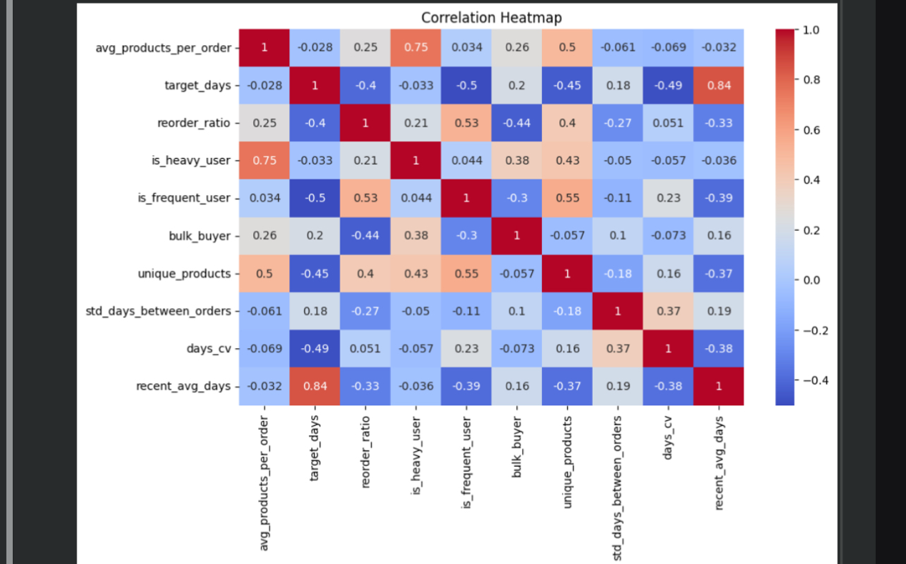
1. Importing libraries:
import matplotlib.pyplot as plt
import seaborn as sns
We imported the tools needed to create visual plots and heatmaps.
2.Creating the figure:
plt.figure(figsize=(10, 6))
We set the size of the plot to make it wide and readable.
- Generating the heatmap
sns.heatmap(df.corr(numeric_only=True), annot=True, cmap='coolwarm')
We created a heatmap to show the correlation between numeric features in the dataset:
df.corr(numeric_only=True) calculates how strongly each pair of columns is related.
annot=True shows the actual correlation values inside the boxes.
cmap='coolwarm' sets the color style (blue = negative, red = positive).
- Adding a title:
plt.title("Correlation Heatmap")
We added a title to explain what the plot shows.
- Displaying the plot
plt.show()

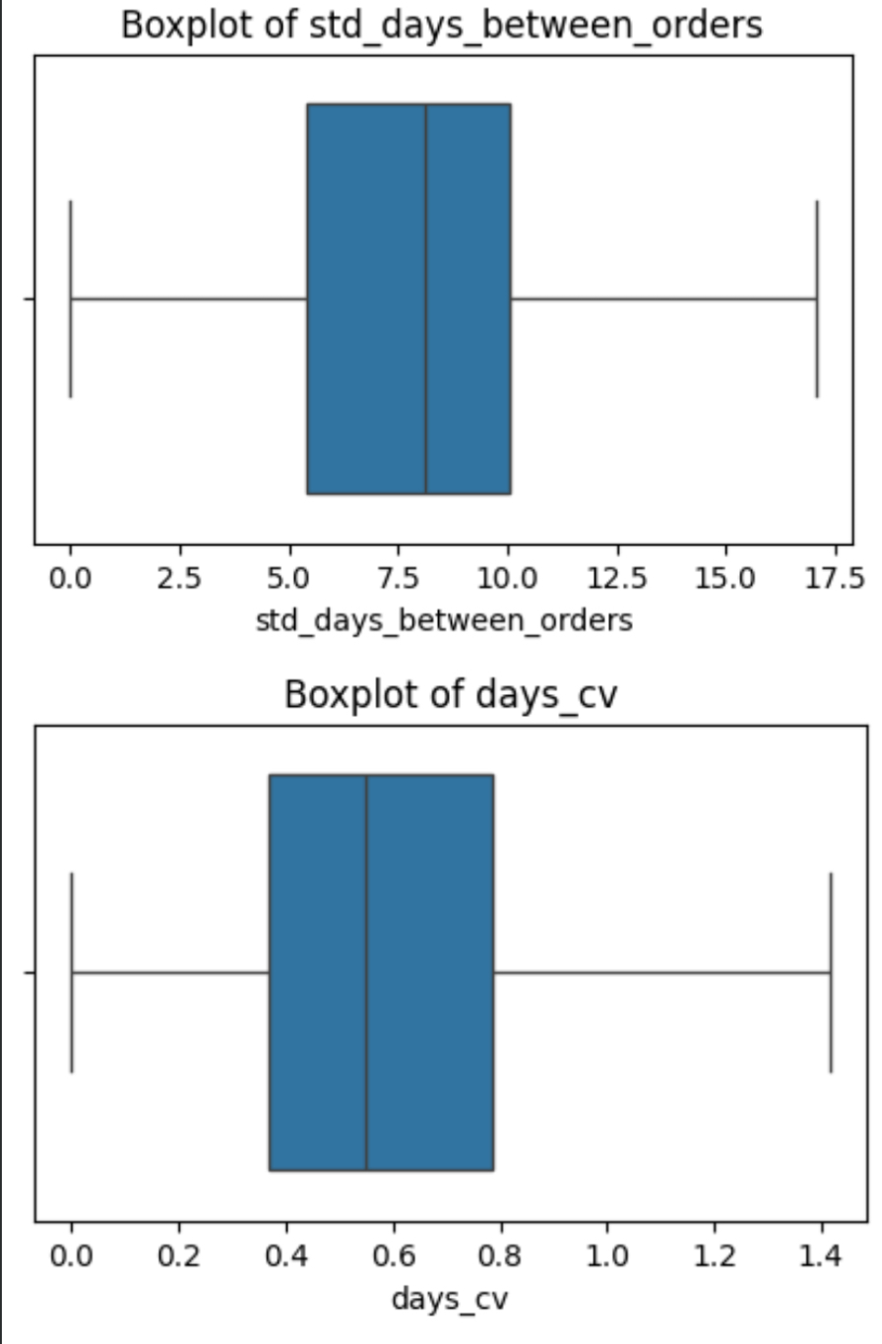
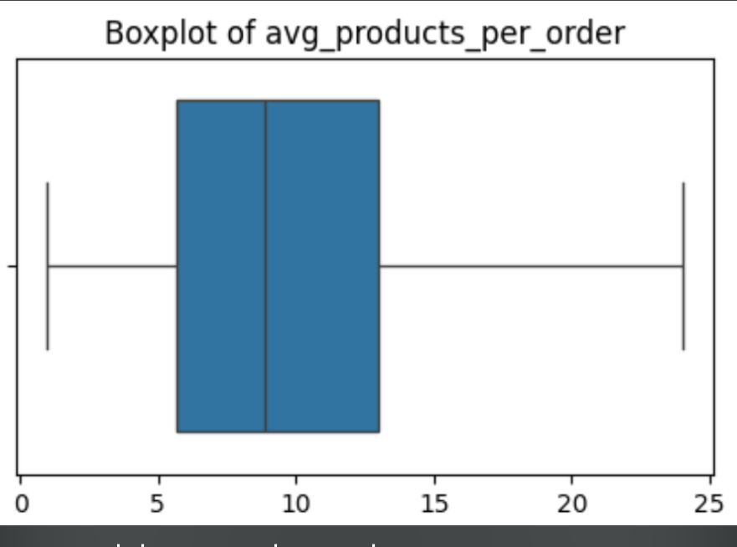
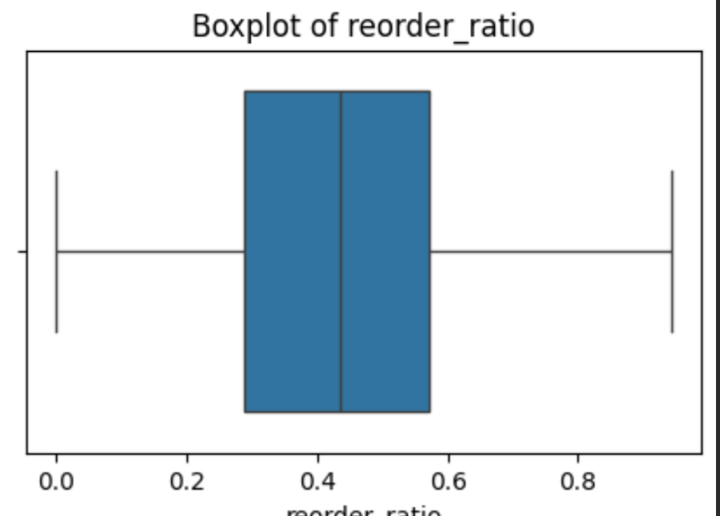
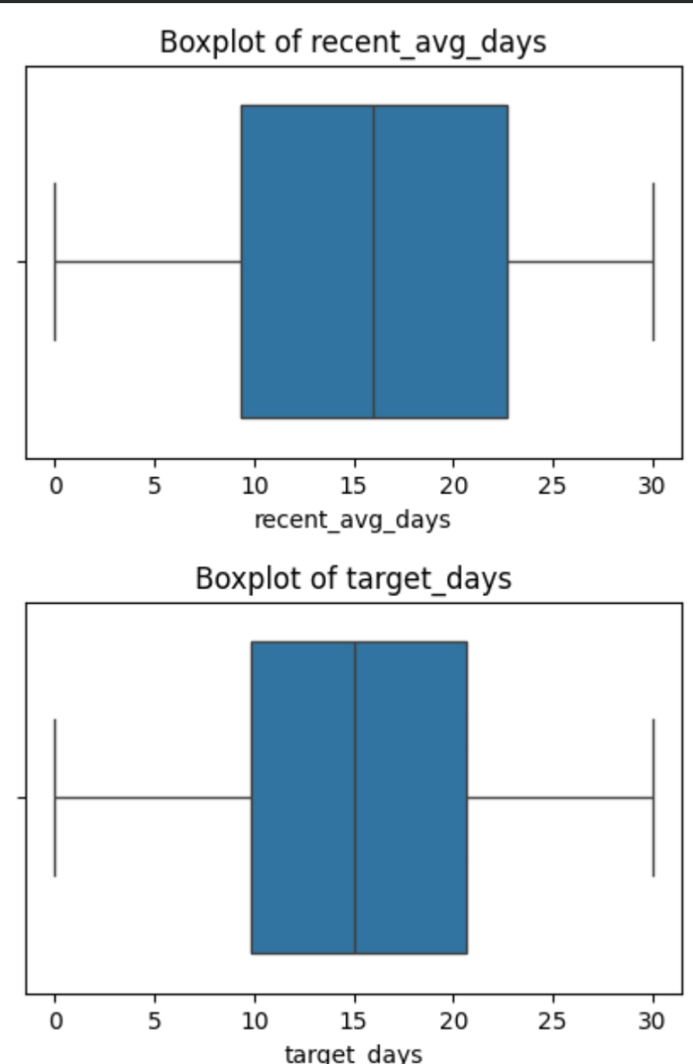

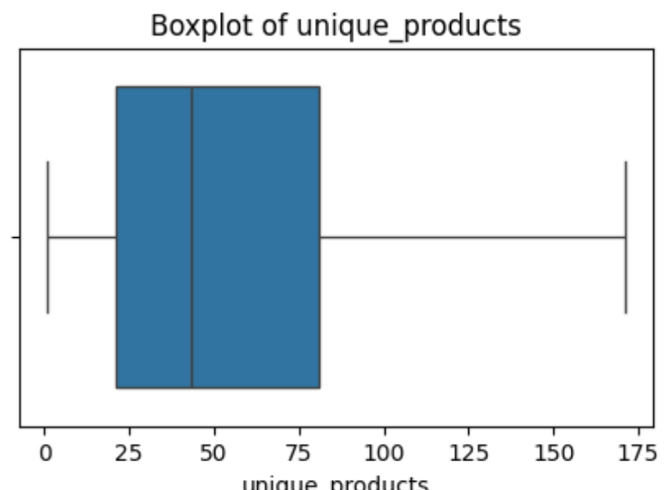
We created boxplots for each numeric column in the dataset.
This helps us see the distribution of values and check for outliers.
Each plot shows how the data is spread, where the middle is, and if there are any extreme values

First Block – Data Scaling
We used StandardScaler to scale the input features.
This means we made all the values have the same range (mean = 0, std = 1).
It helps the model learn better, especially for algorithms sensitive to feature size.
📈 Second Block – Linear Regression Model
We trained a Linear Regression model using the scaled data.
Then we made predictions on the test set.
Finally, we evaluated the model using:
MAE (Mean Absolute Error)
RMSE (Root Mean Squared Error)
R² Score (how well the model fits the data)

Polynomial Features
We created new features by adding polynomial combinations (up to degree 3) of the original inputs.
This helps the model learn more complex patterns.
Ridge Regression Model
We trained a Ridge Regression model, which is like linear regression but
with regularization to reduce overfitting
Model Evaluation
We measured how well the model performs using
R² score for both training and testing
MAE (Mean Absolute Error)
RMSE (Root Mean Squared Error)

Model Selection and Training
We chose Ridge Regression, which is a type of linear regression with regularization to reduce overfitting.
Then we trained the model using the scaled training data
Prediction
We used the trained model to predict the target values for the test data
Model Evaluation
We evaluated the model using
MAE (Mean Absolute Error)
Measures average prediction error
RMSE (Root Mean Squared Error
Penalizes larger errors more
R² Score: Shows how well the model explains the data (closer to 1 = better).

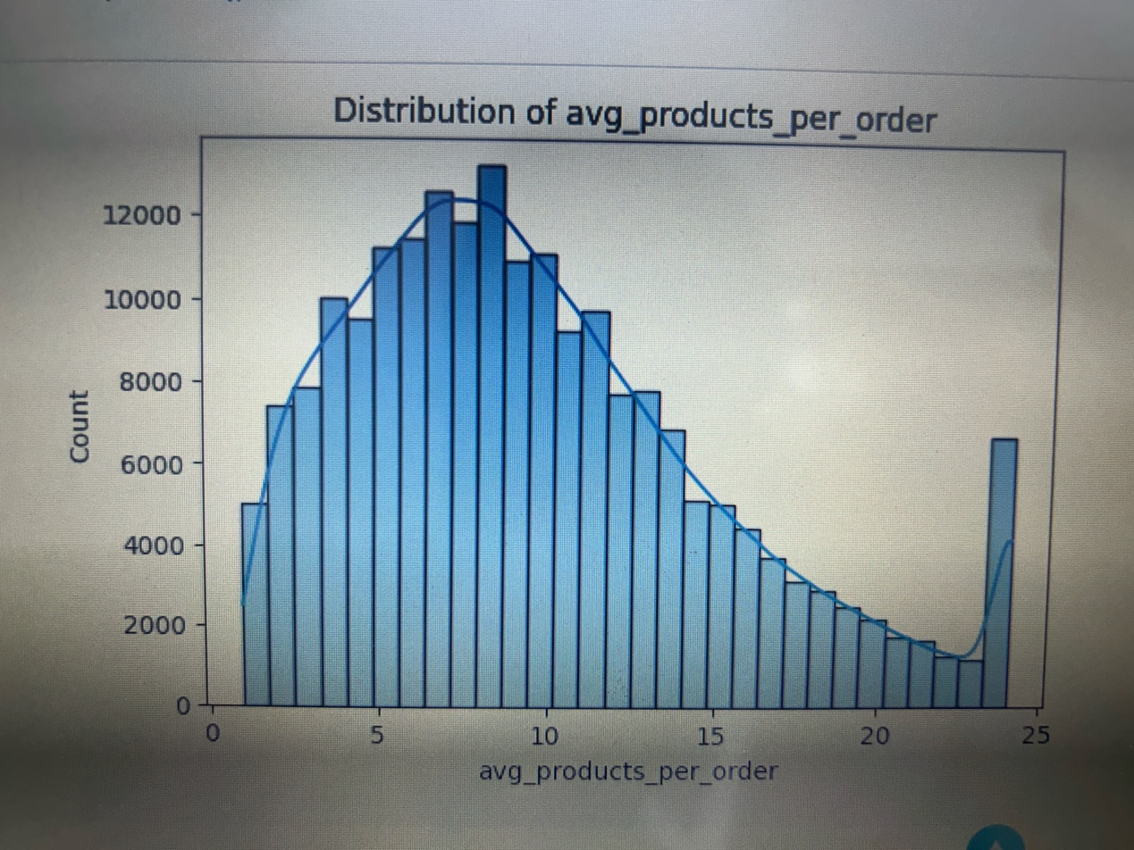
Imported Libraries
We imported the tools needed to create plots and visualizations
Selected Numeric Columns
We listed the numeric columns we want to analyze, like avg_products_per_order, reorder_ratio, target_days, etc.
Plotted Histograms
For each column
We created a histogram to show how the values are distributed.
We added a KDE curve (smooth line) to better understand the shape.
We used 30 bins to divide the values into ranges.
We displayed each plot with a title.

Loop through numeric columns
We looped through each numeric column, except the target column (target_days), to analyze its relationship with the target.
Create scatter plots
We created a scatter plot showing how that feature relates to target_days.
The x-axis is the feature, and the y-axis is the target.
alpha=0.3 makes the points slightly transparent to better see overlapping data.
We added a title to each plot and displayed it.
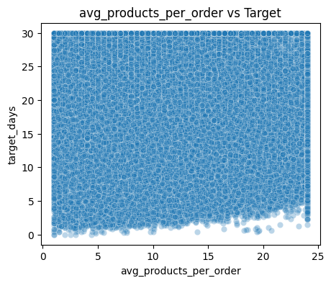

Selected the target column
We focused on the column target_days, which represents the number of days between orders.
Created a histogram
We plotted a histogram to show how the values of target_days are distributed.
The bars show how many users fall into each range of days.
Added a KDE curve:
→ The smooth line (KDE) helps us see the overall shape of the distribution.
Styled the plot
We set the plot size, added a title, and displayed the chart

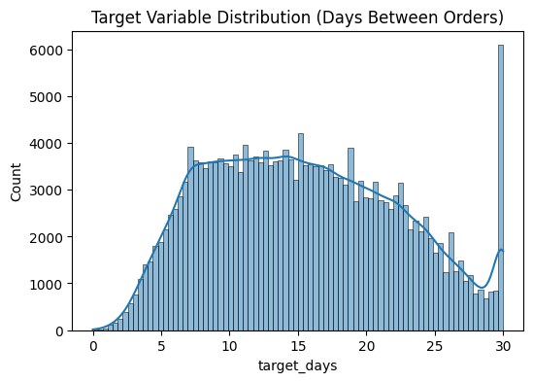

Model evaluation and comparison
Define model names:
We listed the three models we want to compare: Linear, Ridge, and Lasso.
Compute MAE for each model
We calculated the Mean Absolute Error for the predictions from each model and stored the results in a list.
Compute RMSE for each model
We calculated the Root Mean Squared Error for each model’s predictions and stored the results in a list
Compute R² for each model
We calculated the R-squared score for each model’s predictions and stored the results in a list.
Create a comparison table
We built a pandas DataFrame that combines model names with their MAE, RMSE, and R² scores, making it easy to compare performance side by side
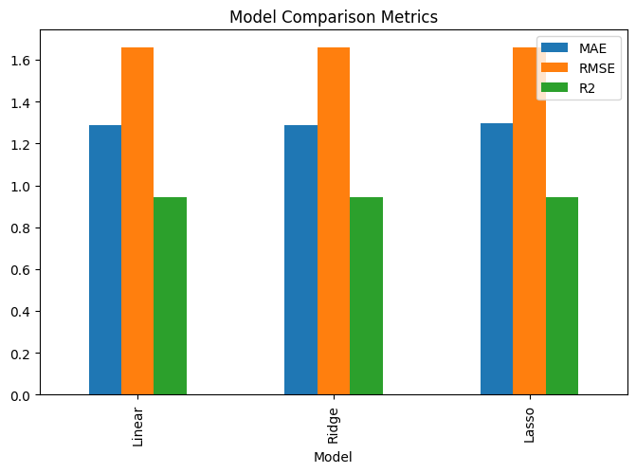

Actual vs predicted visualization for Ridge model
1.Create the figure:
We set the plot size to make the chart square and readable
2. Scatter actual vs predicted:
We plotted a scatter of the true values on the x-axis (y_test) and the Ridge model’s predictions on the y-axis (y_pred_ridge).
The transparency (alpha=0.4) helps visualize dense areas.
3. Add the reference line (perfect prediction):
We drew a red diagonal line from the minimum to the maximum of the actual values.
This line represents ; points exactly on this line mean perfect predictions.
4. Label axes and title:
We labeled x as “Actual Days” and y as “Predicted Days,” and added the title “Actual vs Predicted (Ridge).
